What is Boundary value analysis? Why is it used? Explain with real life example

Boundary value analysis is one of the black box test design techniques that focuses on boundary values of equivalence partitions.

We know that exhaustive testing is impossible so we are not able able to test all the possible combinations. So for not to test all possible combinations using test design techniques Equivalence partitioning and Boundary value analysis. These techniques are closely related that is the reason i’d like to add some information about Equivalence partitioning before explaining Boundary value analysis.

So the idea of equivalence partitioning is to divide test conditions into groups that are considered the same and later use one value from group. For example if an input field accept values from 1 to 100 we divide values into three groups: smaller than 1, from 1 to 100 and more than 100. We assume that all values from the same group produce the same output.

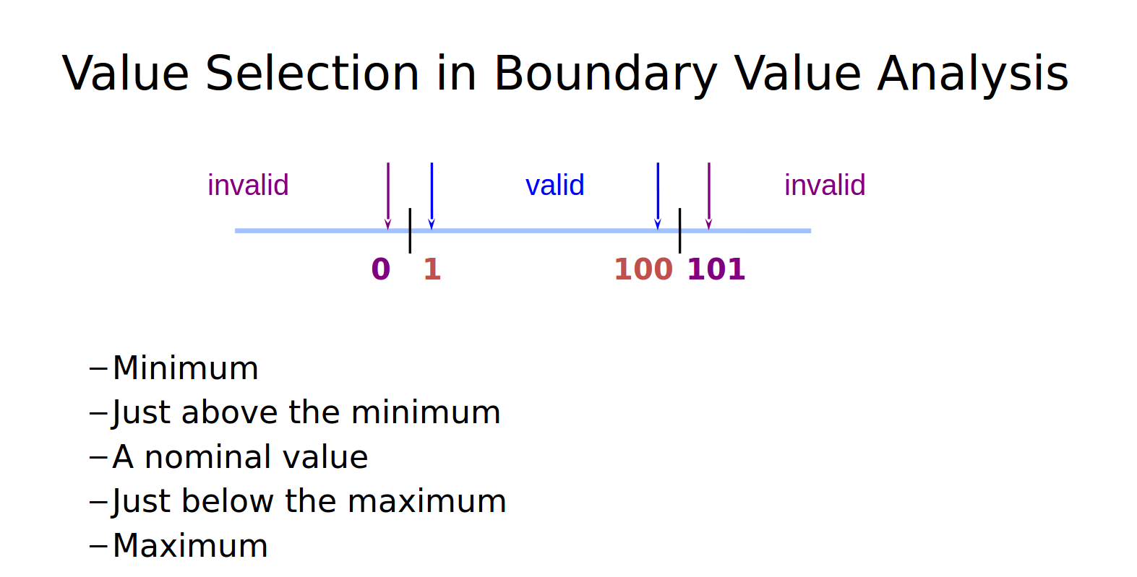TC 1 - Input 0

TC 2 - Input 1

TC 3 - Input 50

TC 4 - Input 100

TC 5 – Input 101

So by 5 test cases we can cover all the input field.

Boundary value analysis is checking the boundary values between these partitions. In this case we’ll take maximum and minimum values of valid partition, that is 1 and 100 and appropriate values of invalid partitions: 0 and 101. This is a very simple example but for more complex cases we might consider that values that are more than 100 have no boundary and how application reacts to 1000, 10000 etc. This is called open boundary. To find the end boundary we might re-read specifications. Actually this is how boundary value technique can be used during the first phases of the software life cycle while reviewing requirements. In this case we might consider a requirement that doesn’t allow entering more than two digits into the input field.